**Spreadsheet**

**Class Six**

**Lab 23**

|  |
| --- |
| Lab Objectives:  * Text Formatting |

Let’s consider a shopping list

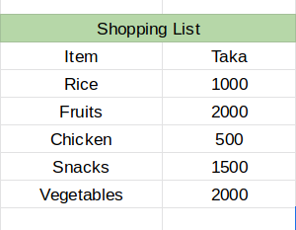

## To change anything just mark the area then hit whatever you want.

# Font

You can use any of your desired font from the font family. To change font mark the are then select any font you like.

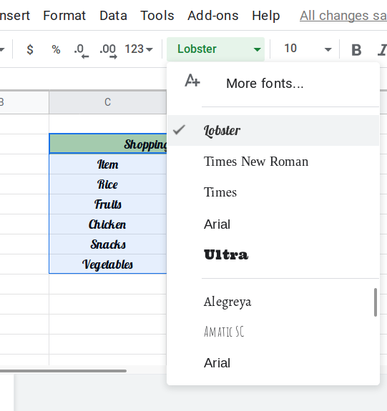

The new look of your shopping list is below

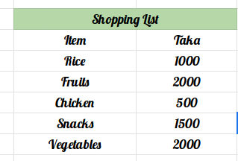

# Font Size

You ca resize your font by mentioning the font size. By default the size is 10, change it to 24 and see

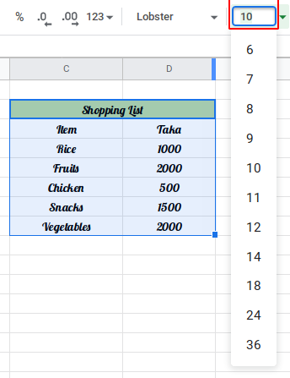

Font size has been changed into 24

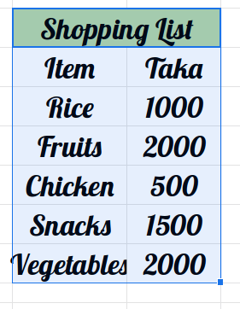

# Bold

Suppose you have used any regular font for your shopping list and you want to bold some specific words. Just mark the area and click on “B” from the menu bar



If we need to bold ‘Item’ and ‘Taka’

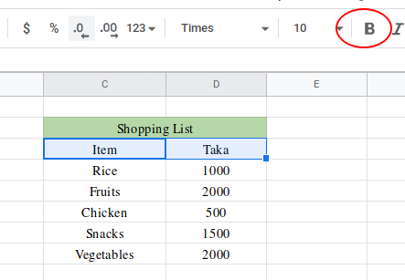

Bold text

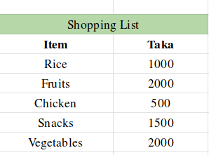

# Italic

To style a font like italic format mark the area and click on “*I* ” from menu bar

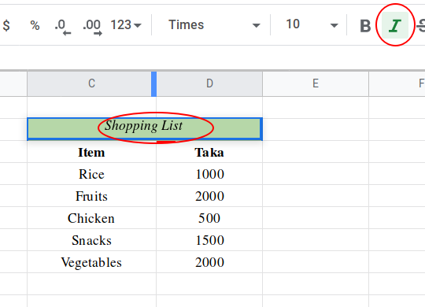

# Border

Suppose you need a border over the area of your Shopping list. Mark the area then click on “Borders” from menu and select which border you want.

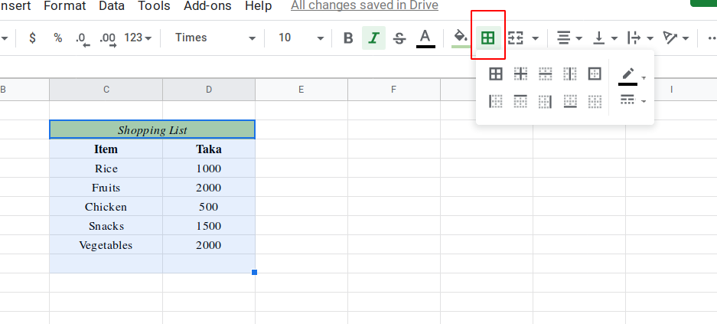

A border will appear

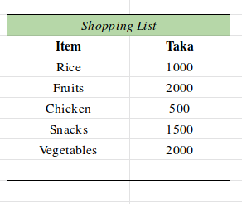

# Alignment

You can align your text to left, middle or right according your list. Mark area and choose alignment

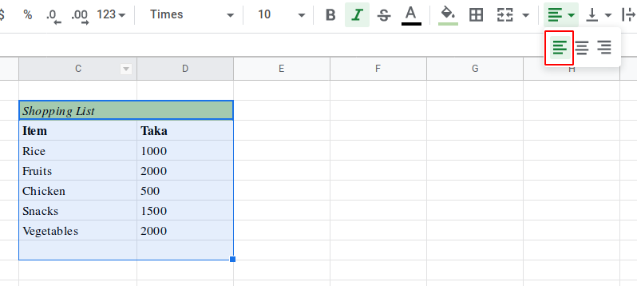

Look , the text of our shopping list goes from middle to left.

Send it to right

